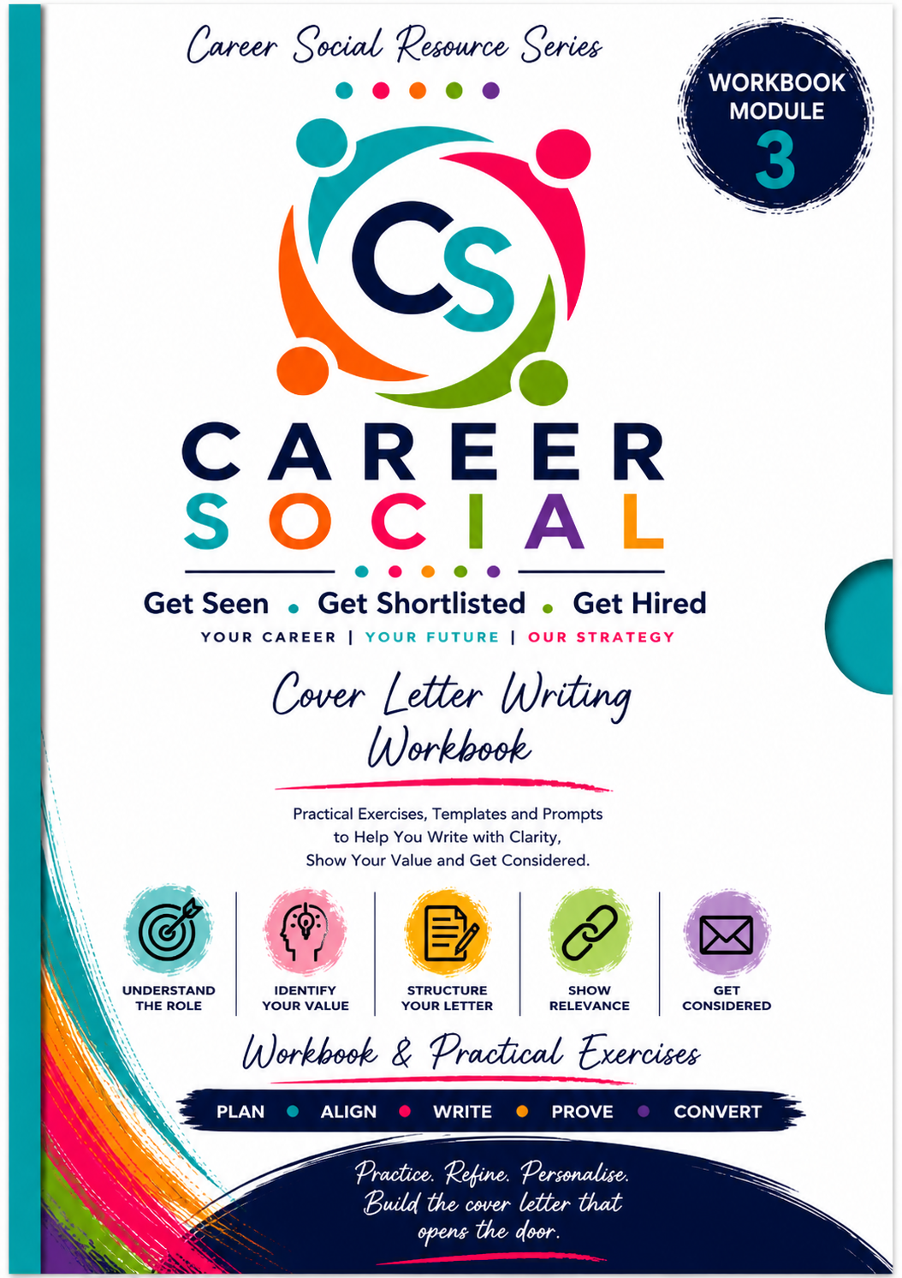
How to Write a Cover Letter That Gets You Considered
Purpose of this workbook
This workbook is designed to help you apply the Cover Letter Writing Guide step by step. It helps you decide whether a cover letter is needed, understand the role, identify the right evidence, build a structured letter, tailor it properly and review it before sending. This is a working document, not a polished final draft.

How to Use This Workbook
Hints and tips before you start
Work through the chapters in order. Do not jump straight to the template. The quality of your cover letter depends on the thinking you do before writing. Use rough notes first, then shape them into clear paragraphs. Keep your answers truthful, specific and role-aligned.
☐ Have the Cover Letter Writing Guide open beside you.
☐ Have the job advert or role description in front of you.
☐ Have your CV available so you can select evidence without repeating everything.
☐ Use this workbook to build a master version and a tailored version.
☐ Do not aim for perfect wording at first; aim for clarity.

Disclaimer & Copyright | The legal bit
This Cover Letter Writing Workbook is provided as part of the Career Social resource library and is intended for personal learning, reflection and job search preparation only.
No part of this workbook may be reproduced, copied, distributed, shared, stored in a retrieval system, uploaded to third-party platforms, sold, adapted, or transmitted in any form or by any means without prior written permission from PCVW Ltd, except for brief quotations used for non-commercial purposes with appropriate credit.
This workbook is intended for informational and educational purposes only. While every effort has been made to provide practical, relevant and professional guidance, Career Social and PCVW Ltd make no guarantees regarding job search outcomes, interview invitations, job offers, salary increases or employment success.
The exercises, prompts, examples and templates are designed to support your thinking and preparation. They should be adapted to your own experience, circumstances, career goals and target roles.
Career Social and PCVW Ltd accept no responsibility for any loss, damage, missed opportunity or disruption arising from the use of this workbook or any decisions made based on its content.
© PCVW Ltd trading as Career Social. All rights reserved.

Workbook Contents
Chapter 1 | What a Cover Letter Actually Needs to Do
Chapter 2 | Why Most Cover Letters Don’t Work
Chapter 3 | When You Should and Shouldn’t Use One
Chapter 4 | Understanding the Role Before You Write
Chapter 5 | Identifying What You Need to Show
Chapter 6 | The Structure of a Strong Cover Letter
Chapter 7 | Opening Paragraph: Getting Straight to the Point
Chapter 8 | Middle Section: Showing Relevance and Fit
Chapter 9 | Evidence: Using Your Experience Properly
Chapter 10 | Closing Paragraph: Ending with Intent
Chapter 11 | Tone, Style and Length
Chapter 12 | Tailoring Without Starting From Scratch
Chapter 13 | Using AI Properly Without Sounding Generic
Chapter 14 | Common Mistakes to Avoid
Chapter 15 | Final Review Before Sending

Chapter 1 | What a Cover Letter Actually Needs to Do
Chapter focus
Understand the role of a cover letter before trying to write one. Your aim is not to repeat the CV, but to frame your relevance and help the reader understand why your application makes sense.
Hint / Tip
A cover letter should answer: Why this role? Why you? Why now? If it does not answer these questions, it is likely too generic.

Workbook Tasks
Why this role?
Write practical reasons why this role makes sense for you. Focus on role fit, sector alignment, responsibilities and direction of travel.

Why you?
List the strongest areas of experience that make you credible for this role.

Why now?
Write any context that explains timing, transition, step-up, relocation, return to work or change of direction.

Reflection
What does this letter need to add that the CV cannot fully explain?

What should the reader understand before they even open or review the CV properly?

Chapter Notes

Chapter Completion Check
☐ I understand the focus of this chapter.
☐ I have completed the workbook tasks for this section.
☐ I have captured notes I can use in my final cover letter.

Chapter 2 | Why Most Cover Letters Don’t Work
Chapter focus
Identify weak cover letter habits before you build your own. Most fail because they are too generic, too long, too repetitive or too focused on what the candidate wants rather than what the role needs.
Hint / Tip
Do not ask “What can I say about myself?” Ask “What does this role need to believe about me?”

Workbook Tasks
Current cover letter habits
If you have used cover letters before, write what you usually include.

Weak language check
List any generic phrases you tend to use, such as “hardworking”, “passionate”, “motivated” or “great fit”.

Replacement language
Rewrite those phrases so they are evidence-led and role-specific.

Reflection
Where have you been repeating your CV instead of framing your relevance?

What would make your letter feel more specific to the employer?

Chapter Notes

Chapter Completion Check
☐ I understand the focus of this chapter.
☐ I have completed the workbook tasks for this section.
☐ I have captured notes I can use in my final cover letter.

Chapter 3 | When You Should and Shouldn’t Use One
Chapter focus
Decide whether the situation requires a full cover letter, a short cover message, or no letter at all.
Hint / Tip
Do not waste time writing long letters for applications where they are unlikely to be read. Use the right level of effort for the situation.

Workbook Tasks
Application situation
Tick or describe the application context: requested cover letter, direct email, recruiter submission, quick apply, career change, gap, relocation, senior role.

Format decision
Decide whether this needs a full letter, short message or no letter.

Reason for decision
Explain why this format is appropriate.

Reflection
Are you writing this because it is useful, or because you feel you “should”?

Would a short message be more effective than a full letter in this situation?

Chapter Notes

Chapter Completion Check
☐ I understand the focus of this chapter.
☐ I have completed the workbook tasks for this section.
☐ I have captured notes I can use in my final cover letter.

Chapter 4 | Understanding the Role Before You Write
Chapter focus
Analyse the job advert before writing. This gives the cover letter direction and stops it becoming generic.
Hint / Tip
Start with the vacancy, not yourself. The employer has already told you what matters; your job is to spot it.

Workbook Tasks
Top 5 requirements
Read the advert and identify the five most important requirements.

Problem behind the role
What does this role appear to be hired to fix, improve, manage, protect or deliver?

Language to mirror naturally
List repeated words, skills, responsibilities or phrases from the advert that truthfully match your experience.

Cover letter focus sentence
Complete: For this role, my cover letter needs to show that I can...

Reflection
What appears most important to this employer?

What would someone need to do well in the first 6-12 months?

Chapter Notes

Chapter Completion Check
☐ I understand the focus of this chapter.
☐ I have completed the workbook tasks for this section.
☐ I have captured notes I can use in my final cover letter.

Chapter 5 | Identifying What You Need to Show
Chapter focus
Select the most relevant evidence. A strong cover letter is selective; it does not try to include everything.
Hint / Tip
Choose evidence that matches the role most closely, shows the right level, demonstrates impact and can be explained briefly.

Workbook Tasks
Requirement to evidence match
Match the top role requirements to examples from your experience.

Strongest 2-3 evidence points
Choose the examples that should appear in the letter.

What to leave out
List details that belong in the CV, not the letter.

Why this role angle
Write the practical reason this role makes sense for you and why you make sense for it.

Reflection
Are you selecting evidence based on the role, or based on what you personally want to talk about?

Which example gives the clearest proof of fit?

Chapter Notes

Chapter Completion Check
☐ I understand the focus of this chapter.
☐ I have completed the workbook tasks for this section.
☐ I have captured notes I can use in my final cover letter.

Chapter 6 | The Structure of a Strong Cover Letter
Chapter focus
Plan the letter before writing. Structure gives you control and keeps the letter easy to read.
Hint / Tip
Use 3-5 short paragraphs. Opening, relevance, evidence, context if needed, closing.

Workbook Tasks
Paragraph plan
Write one sentence explaining what each paragraph needs to do.

Context decision
Do you need a context paragraph? If yes, what does it need to explain?

Length plan
Decide whether this should sit closer to 250, 300 or 400 words.

Reflection
Does the structure guide the reader clearly?

Is anything missing or over-explained?

Chapter Notes

Chapter Completion Check
☐ I understand the focus of this chapter.
☐ I have completed the workbook tasks for this section.
☐ I have captured notes I can use in my final cover letter.

Chapter 7 | Opening Paragraph: Getting Straight to the Point
Chapter focus
Write an opening that names the role and positions you quickly. Avoid flat or uncertain openings.
Hint / Tip
Use this formula: I am applying for the [Role Title] position, bringing experience in [area], with particular strengths in [strengths relevant to role].

Workbook Tasks
Role title
Write the exact role title.

Relevant experience area
What broad experience area should appear in the first sentence?

Relevant strengths
Choose 2-3 strengths most relevant to the role.

Opening draft 1
Draft a direct role-led opening.

Opening draft 2
Draft an alternative opening for career change, return to work, relocation or step-up if relevant.

Reflection
Does the opening feel clear within one sentence?

Have you avoided apologising, over-explaining or sounding uncertain?

Chapter Notes

Chapter Completion Check
☐ I understand the focus of this chapter.
☐ I have completed the workbook tasks for this section.
☐ I have captured notes I can use in my final cover letter.

Chapter 8 | Middle Section: Showing Relevance and Fit
Chapter focus
Connect your experience to the employer’s needs. This is where you show role fit, not just experience.
Hint / Tip
This section should say, in effect: I understand what this role needs, and my experience matches it.

Workbook Tasks
Employer need 1
Write the first key requirement and your matching experience.

Employer need 2
Write the second key requirement and your matching experience.

Employer need 3
Write the third key requirement and your matching experience.

Relevance paragraph draft
Draft a short paragraph connecting your background to the role requirements.

Reflection
Have you linked your experience directly to the role?

Could this paragraph be sent to any employer? If yes, make it more specific.

Chapter Notes

Chapter Completion Check
☐ I understand the focus of this chapter.
☐ I have completed the workbook tasks for this section.
☐ I have captured notes I can use in my final cover letter.

Chapter 9 | Evidence: Using Your Experience Properly
Chapter focus
Add proof. Use 2-3 evidence points that show action, context and outcome.
Hint / Tip
Evidence should be specific and concise. Use metrics where you have them, but scope, scale and consequence also count.

Workbook Tasks
Evidence point 1
Action + context + outcome.

Evidence point 2
Action + context + outcome.

Evidence point 3
Action + context + outcome.

Evidence paragraph draft
Turn the strongest evidence into a short paragraph or 2-3 compact lines.

Reflection
Does this evidence prove what you claimed in the previous paragraph?

Are you including too many examples?

Chapter Notes

Chapter Completion Check
☐ I understand the focus of this chapter.
☐ I have completed the workbook tasks for this section.
☐ I have captured notes I can use in my final cover letter.

Chapter 10 | Closing Paragraph: Ending with Intent
Chapter focus
End with calm confidence. Reinforce interest and invite further conversation without sounding passive.
Hint / Tip
Avoid “I hope you will consider me”. Use “I would welcome the opportunity to discuss...”

Workbook Tasks
Closing focus
What do you want to reinforce in the closing line?

Closing draft 1
Write a concise, confident closing.

Closing draft 2
Write an alternative closing for a more formal or senior role.

Reflection
Does the closing sound confident rather than needy?

Does it reinforce fit without repeating everything?

Chapter Notes

Chapter Completion Check
☐ I understand the focus of this chapter.
☐ I have completed the workbook tasks for this section.
☐ I have captured notes I can use in my final cover letter.

Chapter 11 | Tone, Style and Length
Chapter focus
Make the letter sound professional, clear and human. Remove inflated, generic or robotic wording.
Hint / Tip
Plain English is stronger than over-polished language. Specific beats dramatic.

Workbook Tasks
Tone check
List three words that describe the tone you want: e.g. clear, confident, warm.

Cliché removal
Identify any phrases that sound generic or AI-written.

Rewrite exercise
Rewrite one over-polished sentence in clearer language.

Word count check
Record your current word count and target word count.

Reflection
Does the letter sound like you?

Is it easy to read quickly?

Chapter Notes

Chapter Completion Check
☐ I understand the focus of this chapter.
☐ I have completed the workbook tasks for this section.
☐ I have captured notes I can use in my final cover letter.

Chapter 12 | Tailoring Without Starting From Scratch
Chapter focus
Create a reusable master version and tailor it intelligently for each role.
Hint / Tip
Tailoring means changing emphasis, examples and language - not inventing experience or rewriting everything.

Workbook Tasks
Master cover letter components
List your reusable positioning, transferable strengths and evidence points.

Tailoring checklist for this role
What role title, company name, requirements, examples and language need adjusting?

Tailored version notes
What has changed from the master version?

Reflection
Are you tailoring enough to show relevance?

Are you wasting time rewriting parts that do not need changing?

Chapter Notes

Chapter Completion Check
☐ I understand the focus of this chapter.
☐ I have completed the workbook tasks for this section.
☐ I have captured notes I can use in my final cover letter.

Chapter 13 | Using AI Properly Without Sounding Generic
Chapter focus
Use AI to structure and refine your thinking, not to replace your judgement.
Hint / Tip
AI output is only as good as the input. Give it your CV, the advert, achievements, tone and clear boundaries.

Workbook Tasks
AI input checklist
Tick what you will provide: CV, job advert, target direction, achievements, tone, no invention instruction.

Your AI prompt
Write or adapt the prompt you will use.

AI output review
Check for invented facts, generic wording, excessive length, weak alignment or unnatural tone.

Reflection
Did AI improve clarity or make it more generic?

What edits are needed to make it sound like you?

Chapter Notes

Chapter Completion Check
☐ I understand the focus of this chapter.
☐ I have completed the workbook tasks for this section.
☐ I have captured notes I can use in my final cover letter.

Chapter 14 | Common Mistakes to Avoid
Chapter focus
Audit the letter for the most common issues before sending.
Hint / Tip
The most common problem is not bad writing; it is unclear relevance.

Workbook Tasks
Mistake audit
Tick any issues present: too long, repeats CV, generic, too emotional, apologetic, not role-aligned, AI-sounding, reader has to work too hard.

Fix list
Write the specific changes you need to make.

Reflection
What is weakening the letter most?

What one edit would make the biggest difference?

Chapter Notes

Chapter Completion Check
☐ I understand the focus of this chapter.
☐ I have completed the workbook tasks for this section.
☐ I have captured notes I can use in my final cover letter.

Chapter 15 | Final Review Before Sending
Chapter focus
Review strategically before sending. This is not just proofreading; it is checking fit, clarity and reader impact.
Hint / Tip
Final test: If you were recruiting for this role, would this letter make you want to read the CV properly?

Workbook Tasks
Final review checklist
Check role title, company name, opening, evidence, relevance, word count, tone, spelling and formatting.

Final test answer
Would this letter make the reader want to review the CV properly? Why?

Last edits
List final changes before sending.

Reflection
Does the letter add something useful beyond the CV?

Is the application stronger because this letter exists?

Chapter Notes

Chapter Completion Check
☐ I understand the focus of this chapter.
☐ I have completed the workbook tasks for this section.
☐ I have captured notes I can use in my final cover letter.

Cover Letter Decision Tree
Use this before writing
Answer these questions to decide whether you need a full cover letter, short message or no letter.
☐ The application asks for a cover letter.
☐ I am changing direction.
☐ I need to explain context.
☐ The role is senior, specialist or competitive.
☐ I am applying directly to a company or hiring manager.

Job Advert Analysis Sheet
Role Requirement | Evidence Needed | My Matching Experience | Use in Letter?

Evidence Selection Grid
Evidence Point | Action | Context | Outcome | Strength Shown

Master Cover Letter Builder

Professional positioning

Core strengths

Reusable evidence points

Context or direction wording

Reusable closing paragraph

Tailoring Log
Role / Company | Top Requirements | Evidence Used | Language Mirrored | Date Sent | Outcome

Short Cover Message Templates
Short message template
Hello [Name],
Please find attached my CV for the [Role Title] position. I bring experience in [area], with particular strengths in [strength 1], [strength 2] and [strength 3], which align closely with the requirements of the role.
I would welcome the opportunity to be considered.
Kind regards,
[Name]

AI Prompt Builder
Prompt template
Using the attached CV and job advert, please draft a concise UK English cover letter of around 300-350 words. Focus on aligning my most relevant experience to the role requirements. Do not repeat the CV, do not invent metrics, avoid clichés, and use a professional but natural tone.
My CV evidence to include

Job advert priorities

Tone instructions

Facts AI must not invent

My final edited prompt

Final Sending Checklist
☐ Correct role title
☐ Correct company name
☐ Opening positions me quickly
☐ Evidence is relevant
☐ Adds value beyond CV
☐ Concise and readable
☐ Sounds like me
☐ No generic language
☐ Spelling and formatting checked
☐ Saved using a professional file name

Final Note
This workbook is not here to make you write more, it is here to help you write with more clarity, relevance and intention. A strong cover letter does not explain everything; it frames the right evidence for the right role so the reader understands why your application deserves proper consideration.

